### Alexa, where is the best location for an African Restaurant in Toronto?

### Introduction

Toronto is home to **north** of 17,000 restaurants, cafés, diners and pubs [1]. Asian menu type restaurants in Toronto make up 9.6 percent of the Toronto landscape, 5.3 percent of restaurants in Toronto are European [2] and you will find out African ones make up much less.

Imagine you happen to meet some stakeholders or just out of curiosity; you want to try and find an optimal location for a restaurant, an African one to be specific. This article summarizes how I approached the problem.

Since there are lots of restaurants in Toronto, I will try to detect **locations that are not already crowded with restaurants**. I am also particularly interested in **areas with no African restaurants in vicinity**. I would also prefer locations **as close to the CN Tower as possible**, assuming that first two conditions are met.

Some magic will be used to generate a few promising locations based on this criterion.

### Data

Based on the definition of the problem, these are the factors that will influence the decision:

* The number of existing restaurants in the neighbourhood (any type of restaurant)
* The number of and distance to African restaurants in the neighbourhood, if any

The following data sources will be needed to generate the required information:

* Centres of candidate areas will be generated algorithmically and approximate addresses of centres of those areas will be obtained using **API reverse geocoding.**
* The number of restaurants and their type and location will be obtained using **Foursquare API**
* The coordinates of the CN Tower will be obtained using **Foursquare Maps API geocoding** of address.

### Methodology

I will focus on detecting areas of Toronto that have low restaurant density, particularly those with low number of African restaurants.

Let's assume that the CN tower is the reference point. So let's start by converting the CN tower's address to its latitude and longitude coordinates. The location data is gotten from a 25km radius. This data will have to be cut, sliced and prepared for the analysis. After cooking for a bit, I get the table below.

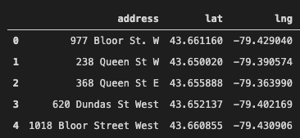

Now that I have my location candidates, using **Foursquare API** to get information on restaurants around the CN Tower, I find out that total number of restaurants in the area is **1116**. This compares terribly to the **10** African restaurants that make up about **0.90%** in the area. The average number of restaurants in the area is **5** and for visualization purposes, here is what the map looks like with **African restaurants in Red** and **Non-African in blue**.

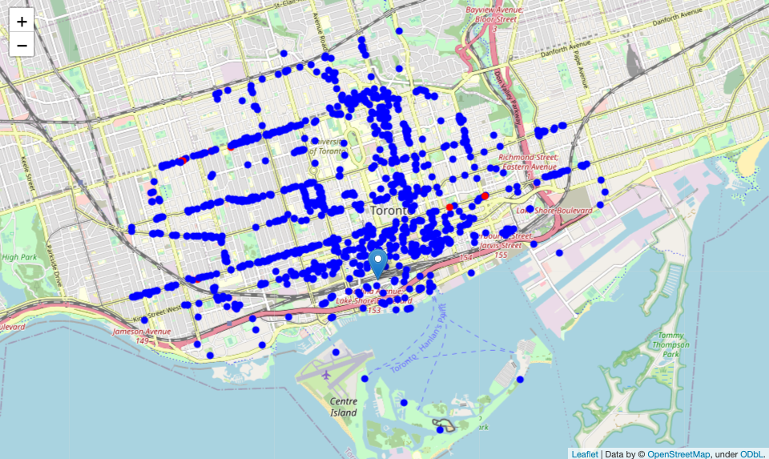

I have also created a map showing **heat-map / density of all restaurants** with a few circles indicating distance of 1km, 2km and 3km from the CN Tower.

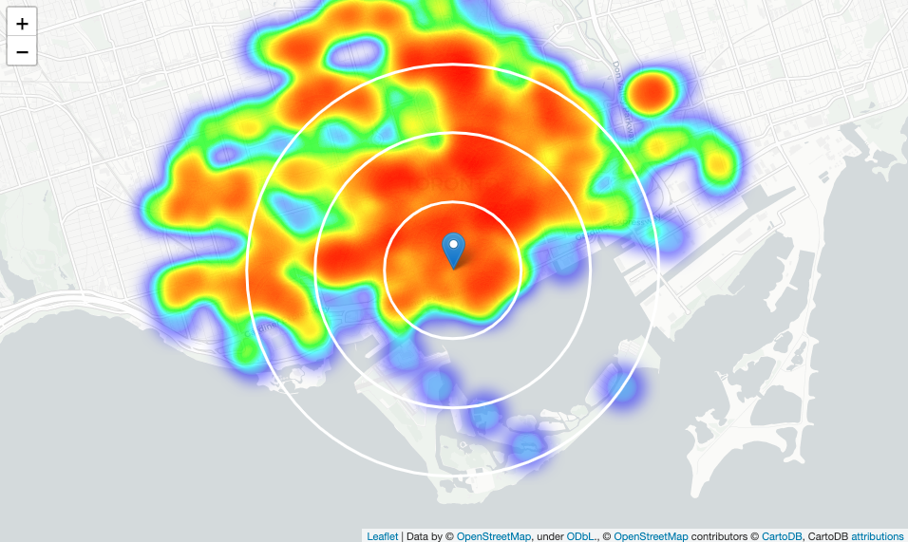

Looking at the map, a few pockets of low restaurant density closest to the CN Tower can be found west, north-west and east from it. I can now create another heat-map map showing **heat-map / density of African restaurants** only.

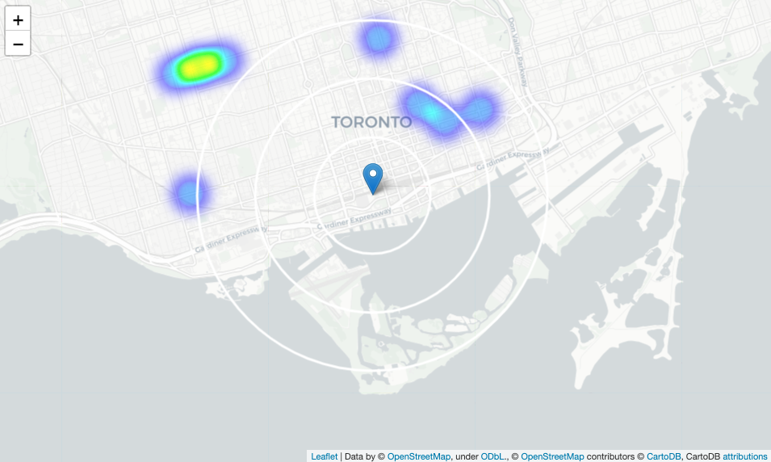

This map is not so **hot.**Based on this I will now focus my analysis on areas west, north-west and east by moving the center of my area of interest and reducing it's size to have a radius of **2.5km**. This covers all the pockets of low restaurant density in Toronto closest to the CN Tower.

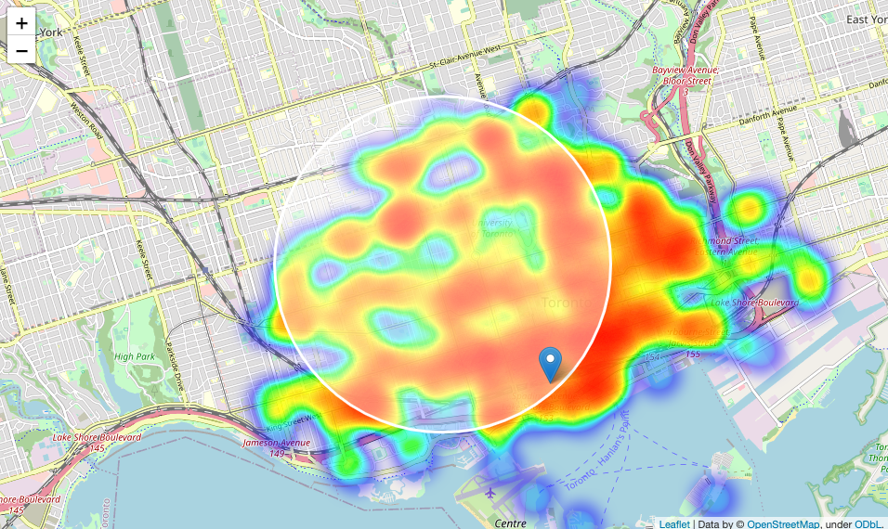

Looking at the map, this places the location candidates mostly in **Kesignton-Chinatown, Yorkville and the Annex**[3].

Now let's calculate two most important things for each location candidate; **the number of restaurants in vicinity** using a radius of 250 meters and**distance to closest African restaurant**. This is what the result set looks like.

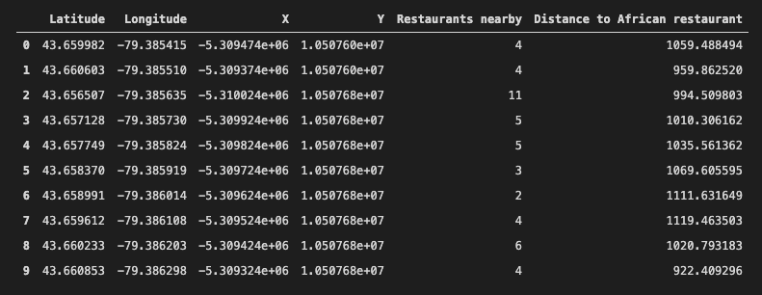

If I filter the location to generate **locations with no more than five restaurants in radius of 250 meters**, and **no African restaurants in radius of 600 meters.**I get the following results:

* Locations with no more than five restaurants nearby:**1203**
* Locations with no African restaurants within 600 metres:**1355**
* Locations with both conditions met:**1027**

On a map

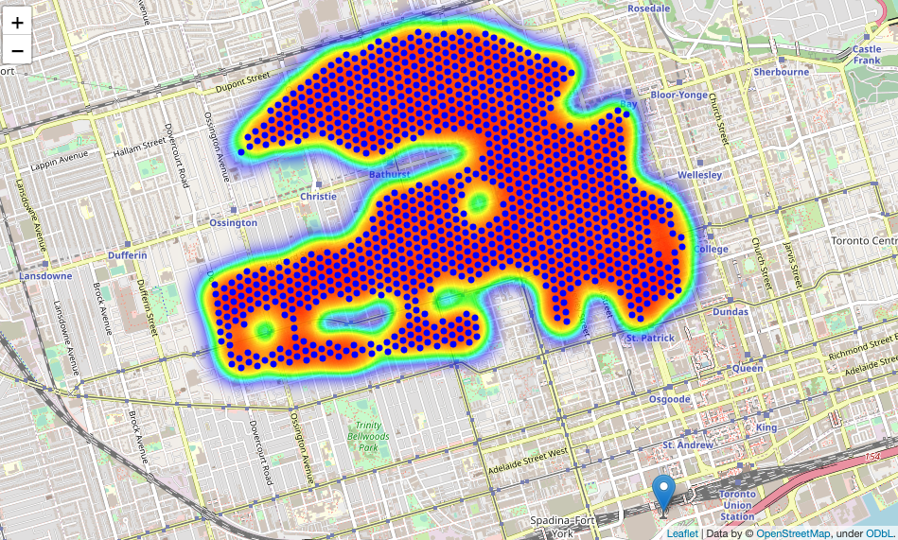

What I have now is a clear indication of zones with low number of restaurants in vicinity, and **no** African restaurants at all nearby.

I will now **cluster** (an unsupervised machine learning algorithm) those locations to create **centres of zones containing good locations**. Those zones, their centres and addresses will be the final result of my analysis. The clusters represent groupings of most of the candidate locations and cluster centres that are placed nicely in the middle of the zones 'rich' with location candidates. The Addresses of these cluster centres will be a good starting point for exploring the neighbourhood's best possible location based on neighbourhood specifics.

Looking at those zones on a map without the heat-map and using shaded areas to indicate the clusters:

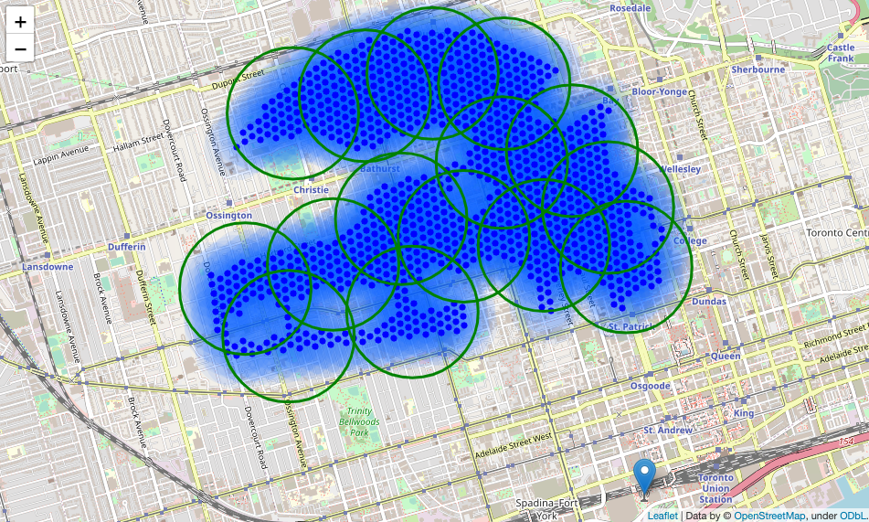

### ****Results****

After**reversing the geocode of those candidate area centres, I have gotten the addresses of 15 locations**that can be presented to the stakeholder.

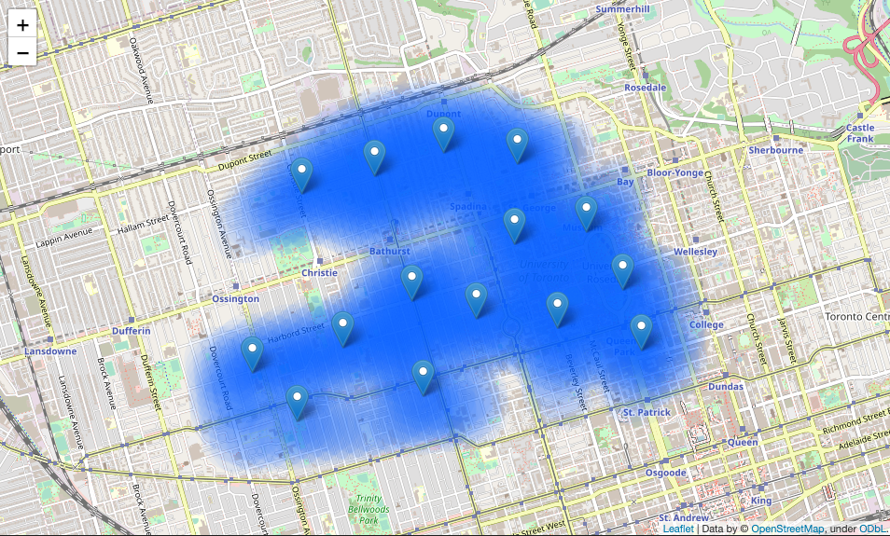

I have created 15 addresses representing centres of zones containing locations with low number of restaurants and no African restaurants nearby, all zones being fairly central with all less than 6km from the CN Tower.

### ****Discussion****

The analysis shows that although there is a great number of restaurants in Toronto, there are pockets of low restaurant density fairly close to centre of the city. Lowest concentration of restaurants was detected west, north-west and east from the CN Tower, so I focused my attention there.

Although zones are shown on map with a radius of 500 meters, their shape is actually very irregular and their centres or addresses should be considered only as a starting point for exploring area neighbourhoods in search for potential restaurant locations. A lot of the zones are located around the University of Toronto which is interesting due to it being popular with international students, fairly close to the CN Tower and well connected by public transport.

### Conclusion

The final decision on an optimal restaurant location will be made by stakeholders based on specific characteristics of neighbourhoods and locations in every recommended zone, taking into consideration additional factors like attractiveness of each location, noise levels and prices.

In the end I was able to cook up some suggestions from my model. This is the magic of data science.

### References

* [1] <https://www.toronto.ca/community-people/health-wellness-care/health-programs-advice/food-safety/dinesafe/#Explore#Search#Nearby>
* [2] <https://www.chd-expert.com/blog/press_release/the-canadian-restaurant-industry-landscape-why-is-toronto-unique/>
* [3] <https://upload.wikimedia.org/wikipedia/commons/2/2f/Toronto_districts_proposal_-_downtown.png>